NAME:

Zulqarnain Ali

ROLL NO:

22011556-114

SUBJECT:

DS&A

SUBMITTED TO:

MS.SEHRISH IJAZ

**Insertion in an array at its start:**

**Program:**

#include<iostream>

using namespace std;

int main()

{

int LA[5]={4,8,9,15};

int n = 4, m;

cout<<"Values in the array = ";

for (int i=0;i<n;i++)

{

cout<<LA[i]<<" ";

}

cout<<"\nEnter the element to insert at the start"<<endl;

cin>>m;

for(int i=n;i>0;i--)

{

LA[i]=LA[i-1];

}

LA[0]=m;

n++;

cout<<"Values of the array after insertion = ";

for(int i=0;i<n;i++)

{

cout<<LA[i]<<" ";

}

}

**Output:**

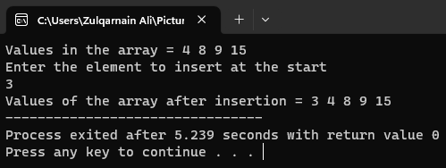

**Insertion in an array at its end:**

**Program:**

#include<iostream>

using namespace std;

int main()

{

int LA[5]={4,8,9,15};

int n=4,m;

cout<<"Values in the array = ";

for (int i=0;i<n;i++)

{

cout<<LA[i]<<" ";

}

cout<<"\nEnter the element to insert at the end" << endl;

cin>>m;

LA[n]=m;

n++;

cout<<"Values of the array after insertion = ";

for(int i=0;i<n;i++)

{

cout<<LA[i]<< " ";

}

}

**Output:**

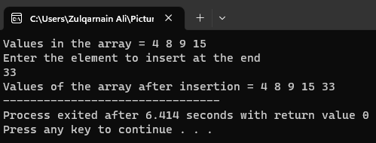

**Insertion in an array at specific point:**

**Program:**

#include<iostream>

using namespace std;

int main()

{

int LA[5]={4,8,9,15};

int value,loc;

cout<<"Values in an array = ";

for(int i=0;i<4;i++)

{

cout<<LA[i]<<" ";

}

cout<<"\nEnter value to insert"<<endl;

cin>>value;

cout<<"Enter location of a value"<<endl;

cin>>loc;

for(int i=4;i>loc;i--)

{

LA[i+1]=LA[i];

LA[i]=LA[i-1];

}

LA[loc]=value;

for(int i=0;i<=4;i++)

{

cout<<"Value in LA "<<i<<" = "<<LA[i]<<endl;

}

}

**Output:**

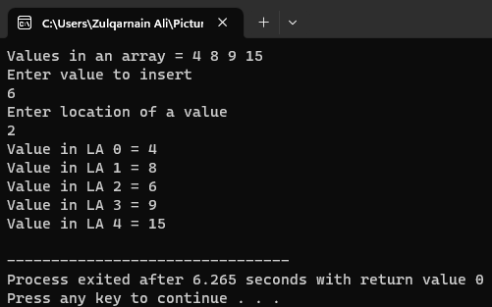

**Deletion in an array:**

**Program:**

#include<iostream>

using namespace std;

int main()

{

int LA[4]={4,8,9,15},t=4,elem,j,found=0;

cout<<"Values in an array = ";

for(int i=0;i<4;i++)

{

cout<<LA[i]<<" ";

}

cout<<"\nEnter Element to Delete: ";

cin>>elem;

for(int i=0;i<t;i++)

{

if(LA[i]==elem)

{

for(j=i;j<(t-1);j++)

LA[j]=LA[j+1];

found++;

i--;

t--;

}

}

if(found==0)

cout<<"Element doesn't found in the Array"<<endl;

else

cout<<"Element Deleted Successfully"<<endl;

cout<<"Values in an array after deletion = ";

for(int i=0;i<t;i++)

{

cout<<LA[i]<<" ";

}

}

**Output:**

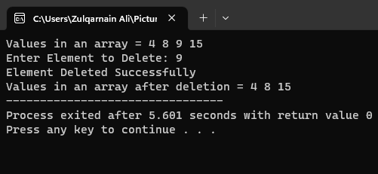

**Updating element in an array:**

**Program:**

#include<iostream>

using namespace std;

int main()

{

int LA[4] = {4, 8, 9, 15};

int n = 4;

cout << "Values in the array = ";

for (int i = 0; i < n; i++)

{

cout << LA[i] << " ";

}

int u,newvalue;

cout<<"\nEnter the index of the element to update: ";

cin>>u;

cout<<"Enter the new value: ";

cin>>newvalue;

LA[u]=newvalue;

cout<<"Values of the array after update = ";

for(int i=0;i<n;i++)

{

cout<<LA[i]<<" ";

}

}

**Output:**

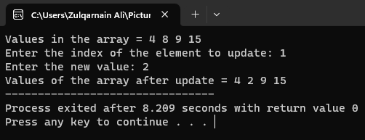

**Linear searching in an array:**

**Program:**

#include<iostream>

using namespace std;

int main()

{

int LA[4]={4,8,9,15},num,index;

cout<<"Values in an array = ";

for(int i=0;i<4;i++)

{

cout<<LA[i]<<" ";

}

cout<<"\nEnter a Number to Search: ";

cin>>num;

for(int i=0; i<4; i++)

{

if(LA[i]==num)

{

index = i;

break;

}

}

cout<<"Element found at Index no = "<<index<<endl;

}

**Output:**

